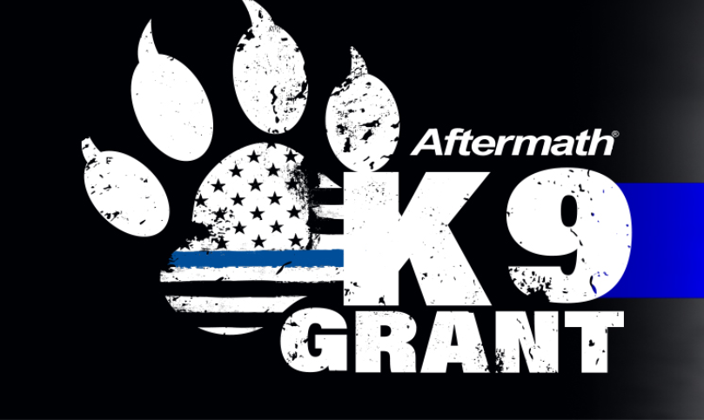
MEDIA ALERT
DATE:
CONTACT:

Local K9 Grant Voting Event: [INSERT LOCAL POLICE DEPARTMENT K9 PROGRAM] is asking for your help to earn the 2022 Aftermath K9 Grant!
The Aftermath K9 Grant will award a total of $15,000 in grants to the top eight (8) agencies to create or maintain a K9 unit, purchase safety equipment, or support officer training. Winners are selected by local communities!

When: Voting is open now through Oct. 31

Where: Visit www.aftermath.com/k9-grant to vote for [INSERT NAME OF LOCAL AGENCY PROGRAM OR SPECIFIC K9] or vote on Facebook(@AftermathCares) or Instagram(@AftermathK9Grant) by following the accounts, then like and comment on daily posts with the agency name, city and state.

Details: You can vote once every 24 hours. Winners will be announced Nov. 3.

Contact: Media is welcomed and encouraged to visit to local agency to learn more about K9 program and interview officers by contacting NAME, EMAIL, (xxx) xxx-xxxx.

###

